daily visits to www.wisconsinstories.org
January 2003
page views  - page views: 13,928  - average per day: 449  - average per unique visitor: 3  visits  - 5,738  - average per day: 185  visitors  - unique visitors: 3,598  - visitors who visit more than once: 12.7% | 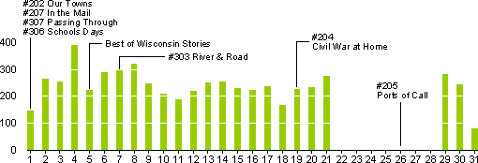  Visits to www.wisconsinstories.org during January 2003 marked with WPT History broadcasts.
February 2003  page views  - page views: 15,612  - average per day: 557  - average per unique visitor: 3  visits  - 6,998  - average per day: 249  visitors  - unique visitors: 3,996  - visitors who visit more than once: 12.9% | 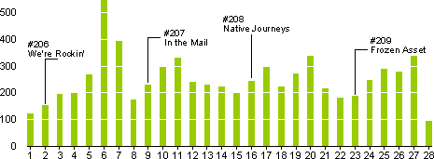  Visits to www.wisconsinstories.org during February 2003 marked with WPT History broadcasts.
daily visits to www.wisconsinstories.org
March 2003  page views  - page views: 24,486  - average per day: 789  - average per unique visitor: 5  visits  - 6,749  - average per day: 217  visitors  - unique visitors: 4,098  - visitors who visit more than once: 13.1% | 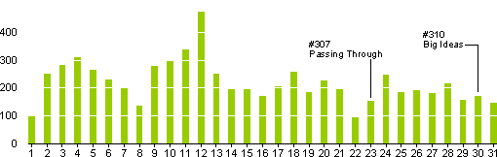  Visits to www.wisconsinstories.org during March 2003 marked with WPT History broadcasts.
April 2003  page views  - page views: 24,523  - average per day: 817  - average per unique visitor: 5  visits  - 6,740  - average per day: 224  visitors  - unique visitors: 4,144  - visitors who visit more than once: 13.% | 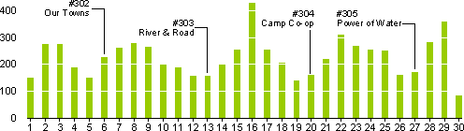  Visits to www.wisconsinstories.org during April 2003 marked with WPT History broadcasts.
daily visits to www.wisconsinstories.org
May 2003  page views  - page views: 28,903 (2,182 for WWII)  - average per day: 932 (70 for WWII)  - average per unique visitor: 5  (7 for WWII)  visits  - 7,930 (610 for WWII)  - average per day: 255 (19 for WWII)  visitors  - unique visitors: 4.229 (303 for WWII)  - visitors who visit more than once: 17% (24% for WWII) | 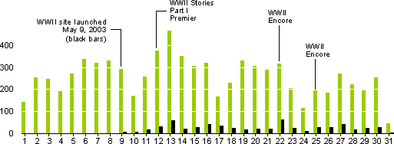  Visits to www.wisconsinstories.org during May 2003 marked with WPT History broadcasts. WWII traffic is solid black.
June 2003  page views  - page views: 21,779 (2,432 for WWII)  - average per day: 725 (81 for WWII)  - average per unique visitor: 6  (8 for WWII)  visits  - 5,333 (793 for WWII)  - average per day: 177 (26 for WWII)  visitors  - unique visitors: 3.334 (292 for WWII)  - visitors who visit more than once: 12%  (22% for WWII) | 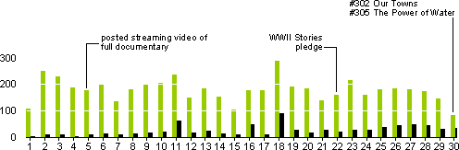  Visits to www.wisconsinstories.org during June 2003 marked with WPT History broadcasts and Web site updates.  WWII traffic is solid black.
daily visits to www.wisconsinstories.org
July 2003  page views  - page views: 22,926 (2,825 for WWII)  - average per day: 739 (91 for WWII)  - average per unique visitor: 6  (5 for WWII)  visits  - 6,141 (1,280 for WWII)  - average per day: 198 (41 for WWII)  visitors  - unique visitors: 3,356 (539 for WWII)  - visitors who visit more than once: 15%  (26% for WWII) | 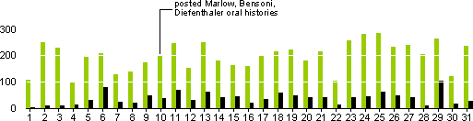  Visits to www.wisconsinstories.org during July 2003 marked with Web site updates. WWII traffic is solid black.

