August Derleth Society 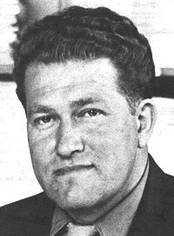
Box 481 Sauk City, WI 53583 USA

James E. Kirchstein
3838 State Road 78
Mount Horeb, WI 53572
12 December, 2009

Dear Jim:

This letter to acknowledge your donation of production costs for the August Derleth Society Archive Project, as depicted on the attachment to this letter. Your donation is accepted on behalf of the board members of the August Derleth Society.

Sincerely,

Kay Price Perry Huntoon
Executive Secretary President
Attachment: ADS Archives listing

